2) For figure 1
figure_1
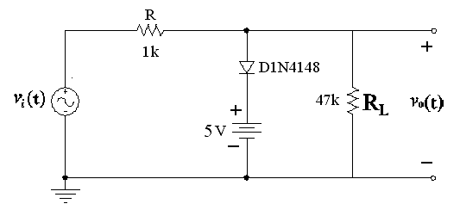
a)

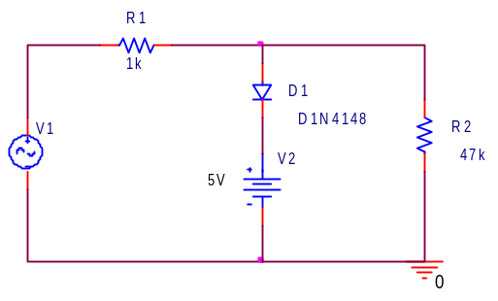
Şekil 1

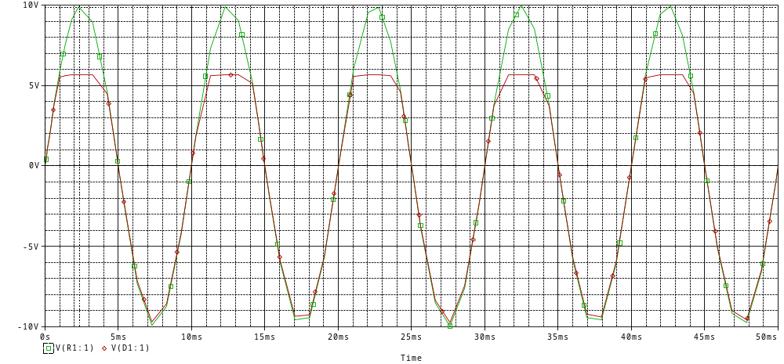
Grafik 1
b) We reverse the diyote and we do that +5V to -5V
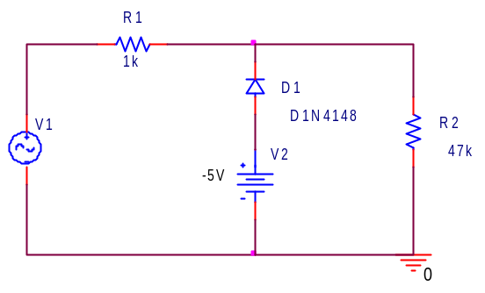
Şekil 2
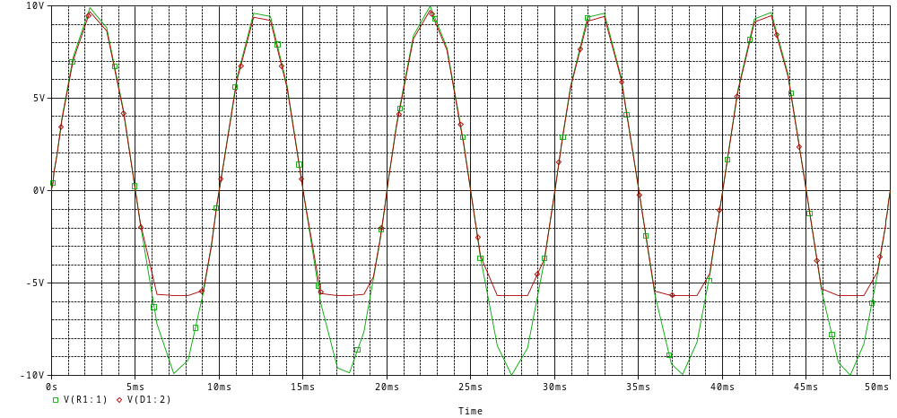
Grafik 2

3) a)
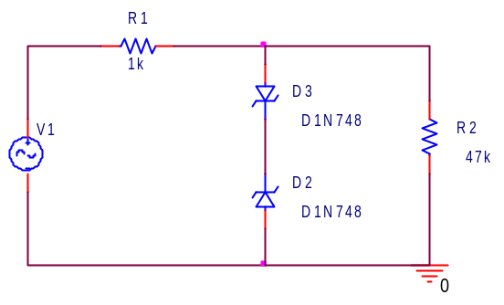
Şekil 3
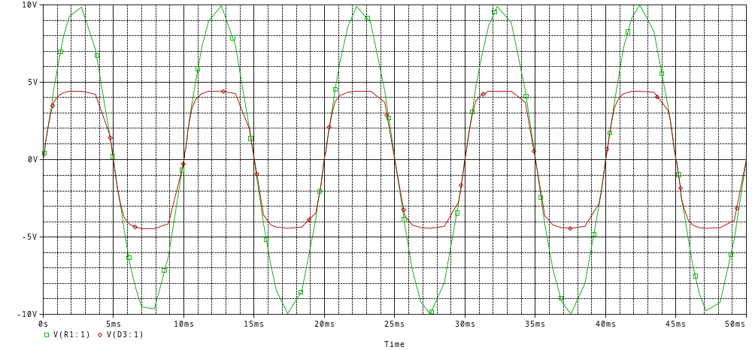
Grafik 3

b)We reverse both diyode and waveforms do not change.Because not only one diyode change; two diyode change. So output do not change.Two of them are same so i do not copy here…
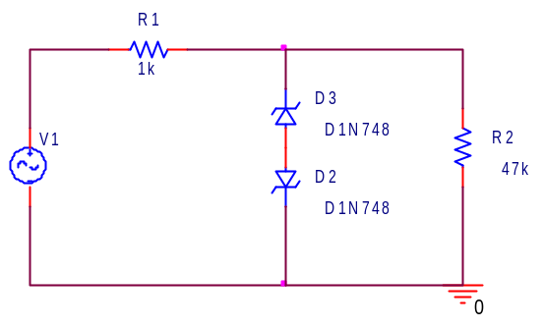
Şekil 4
5) a)
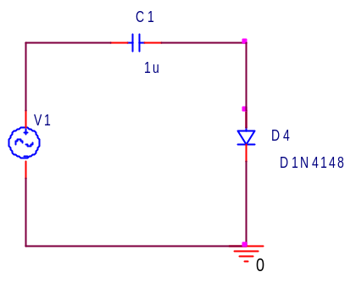
Şekil 5

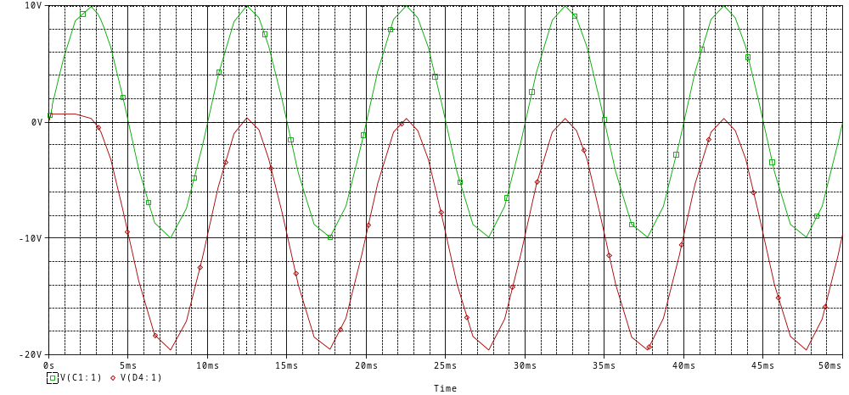
Grafik 4

b)
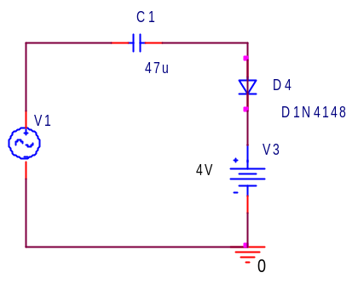
Şekil 6

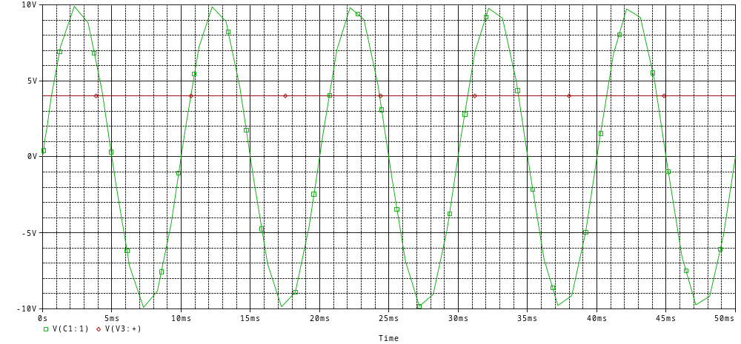
Grafik 5

c)
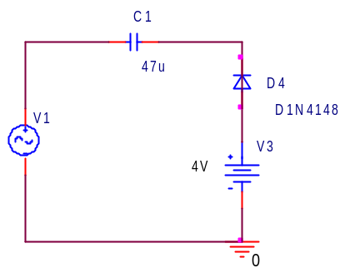
Şekil 7
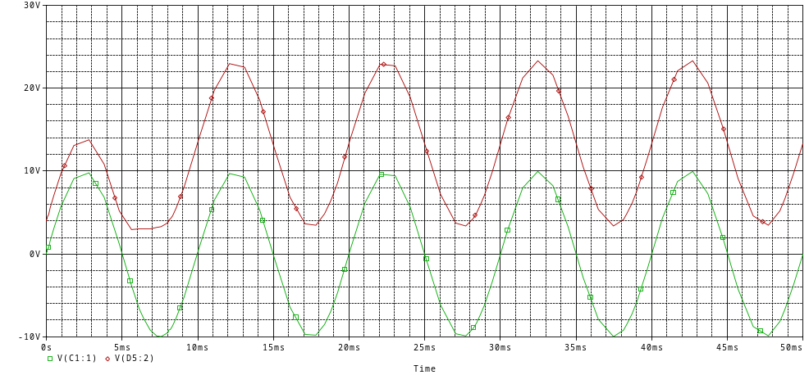
Grafik 6
6)
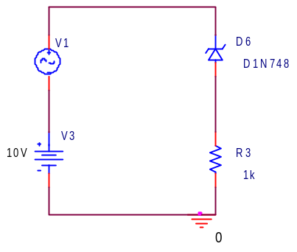
Şekil 8

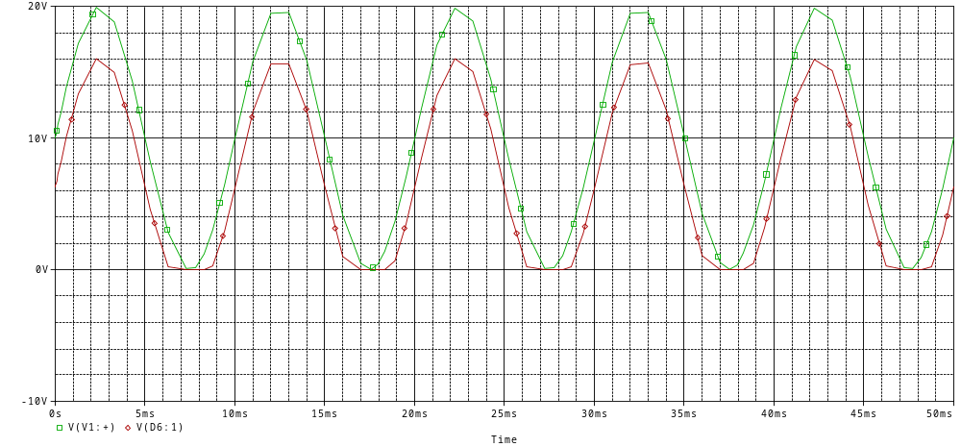
Grafik 7



BAŞKENT UNIVERSITY
ELECTRIC & ELECTRONICS ENGINEERING

EEM 214 ~ ELECTRONICS–I
LABORATORY
PRELIMINARY WORK

Experiment Name : Diode Clipping & Clamping Circuits
Experiment Number : 5

Student Name : Buğra Bayram
Student Number :20193272
Section Number : | Experiment Day: 28.03.2005

